NPS 2320030205

EXPERIMENT – 6 N. Manasa Lahari

AIM: Implementation of Smart home using Cisco packet tracer and verify the configuration

APPARATUS REQUIRED: Laptop-PT, Switch, Router, Server, Fan, Door, Light, Garage Door, Window, Copper Straight-Through cable, Copper cross-Over cable.

Procedure:

1)Connect laptop to Switch and server to switch with Copper Straight-Through cable

2)Connect Switch to router with Copper cross-Over cable

3) Drag fan, door, light, garage door, window

Step1:

Configure ip address for laptop

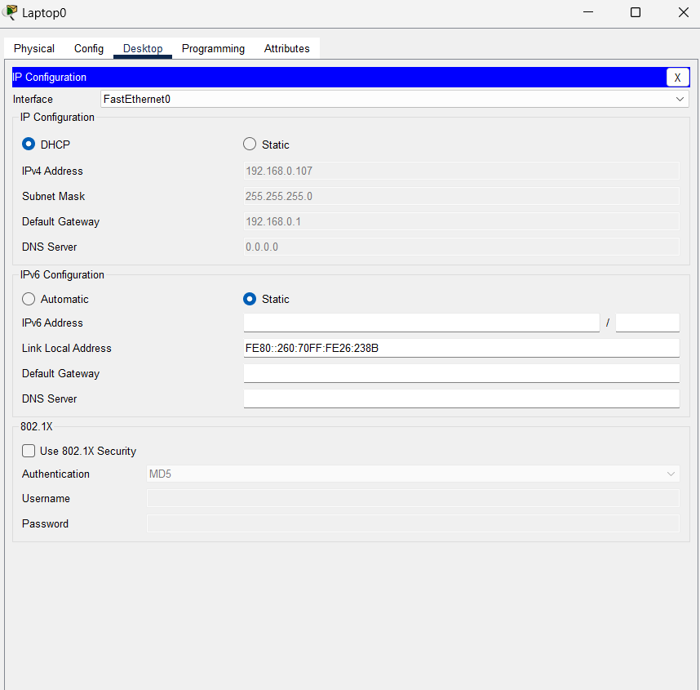

Configure server

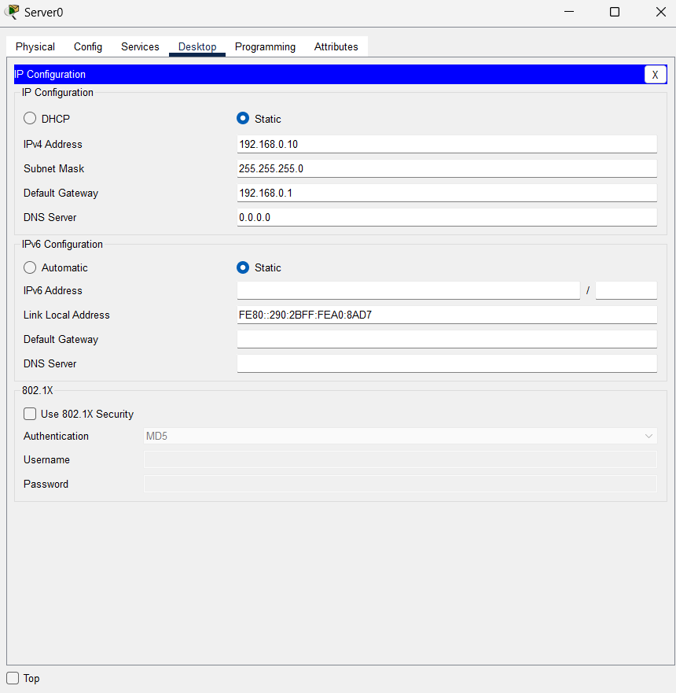

Configure router

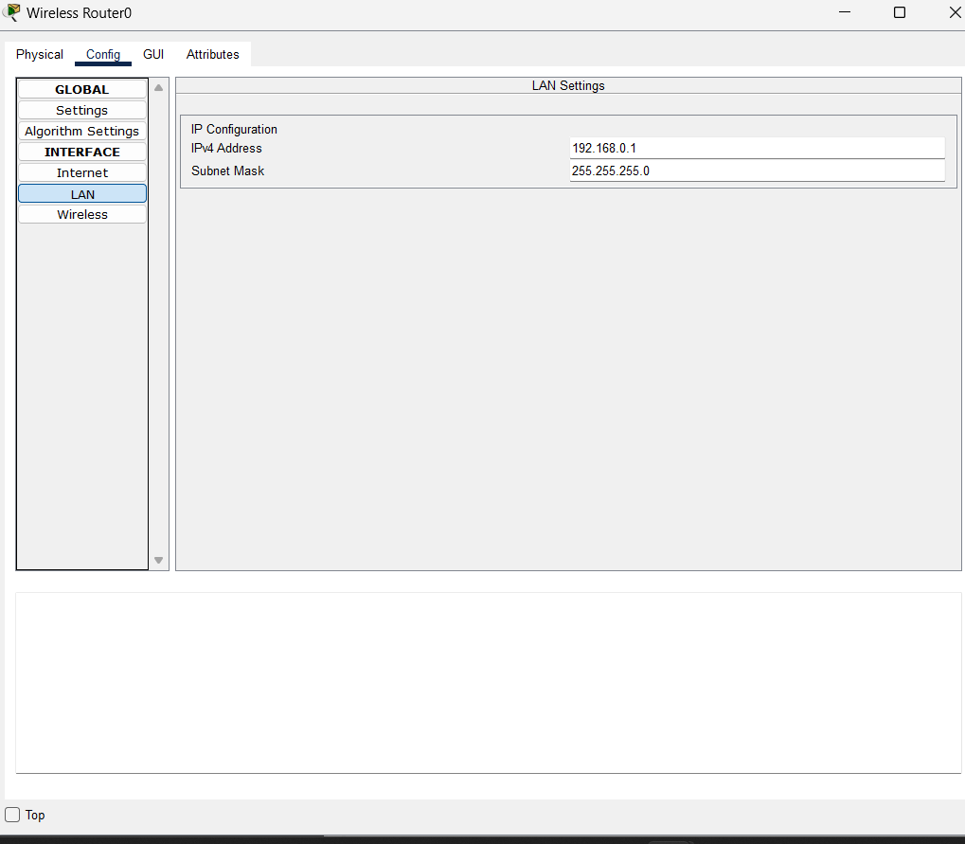

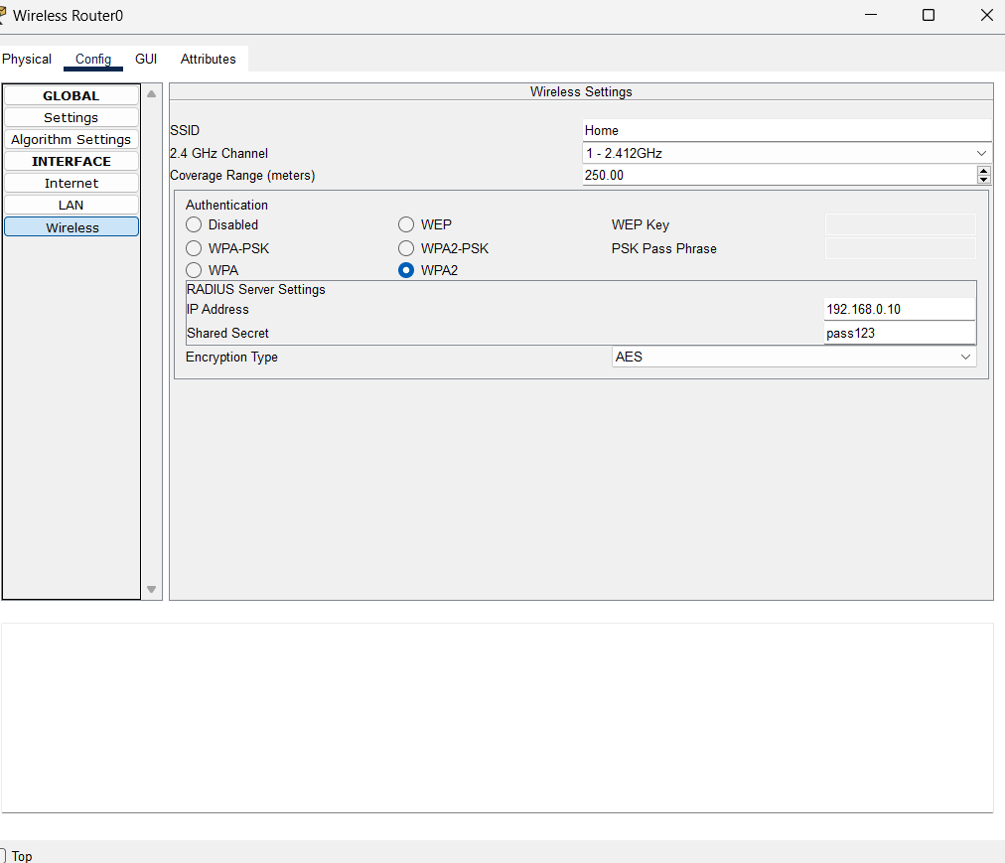

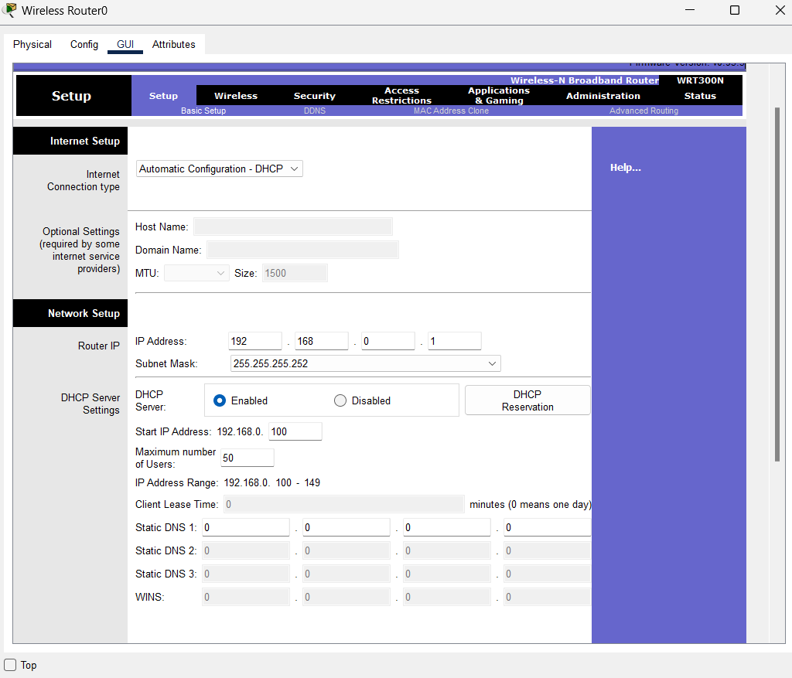

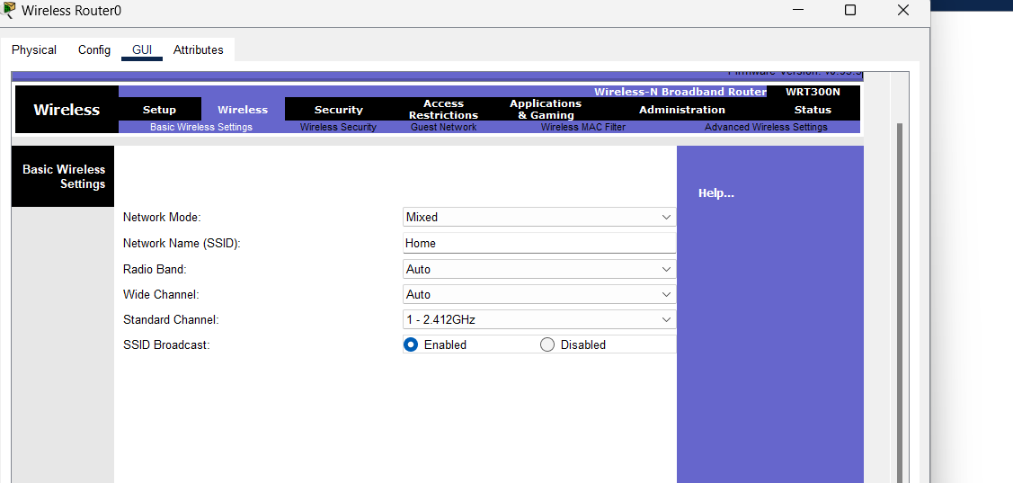

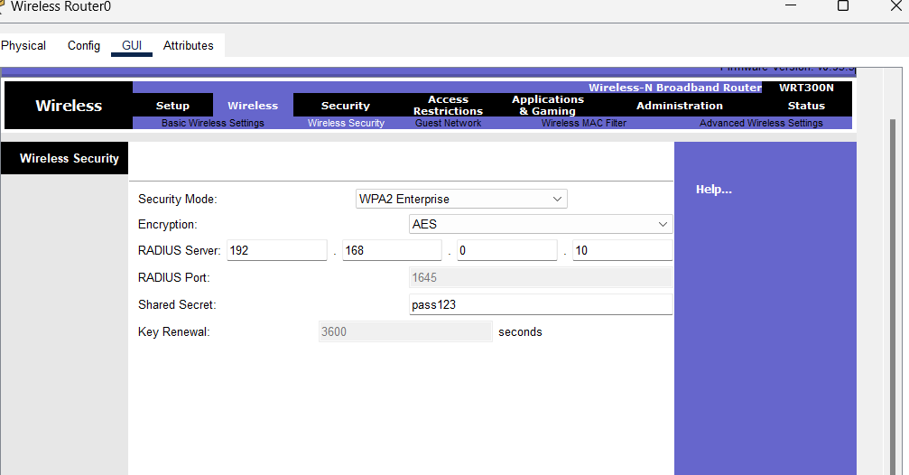

Connect all Fan, Door, Light, Garage Door, Window

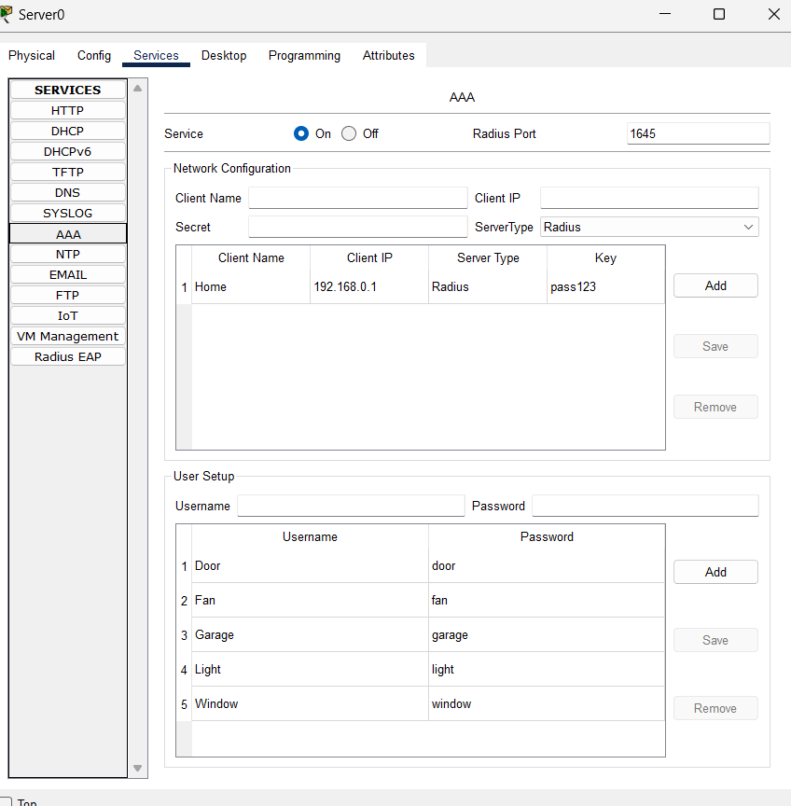

1) fan

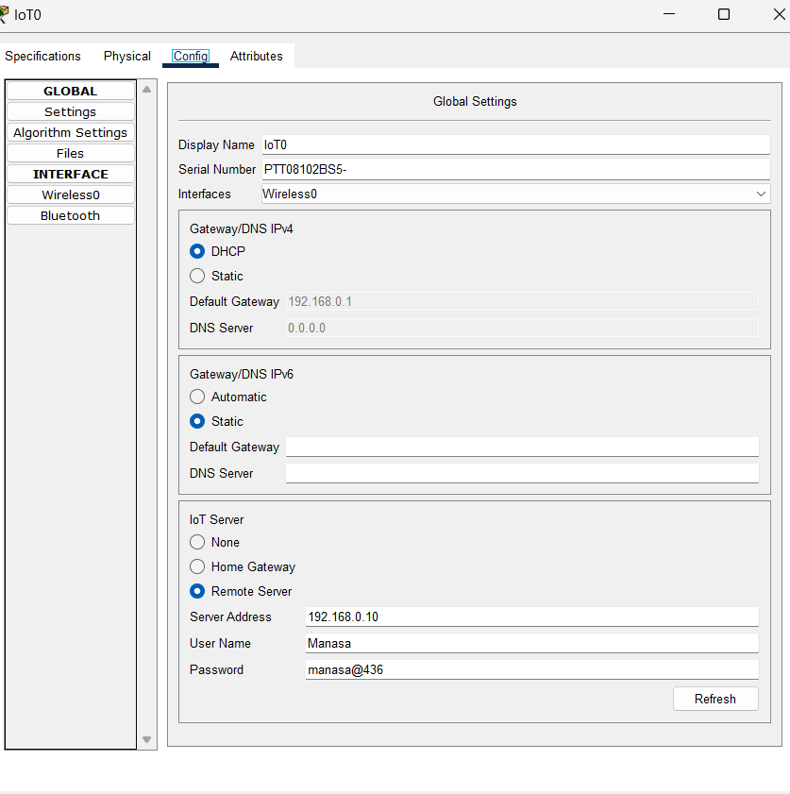

2) door

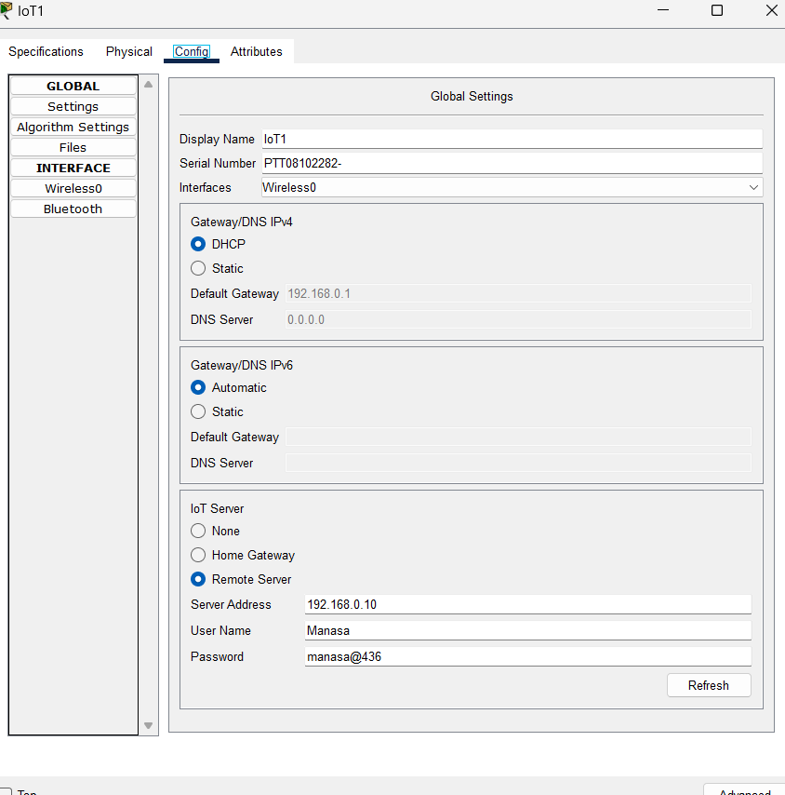

Same we have to do for Light, Garage Door, Window

Next we can operate all

Laptop->desktop->iot monitor

